https://www.jdoodle.com/embed/v0/5WtA
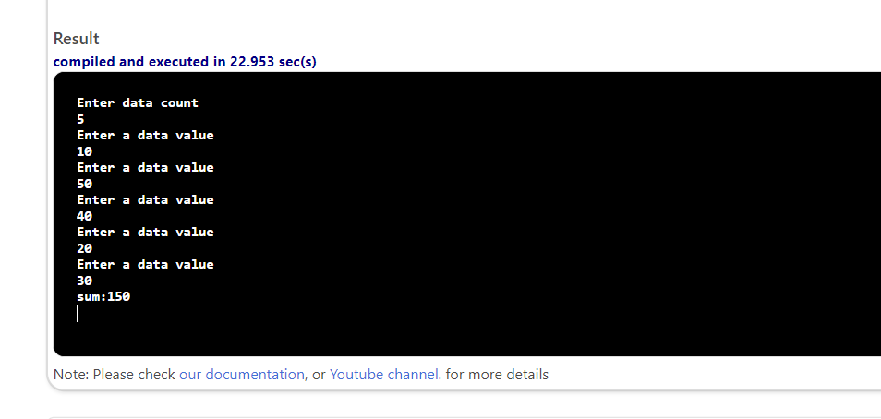

#include <iostream>

using namespace std;

int main() {
int sum;
int num;
int dataCount;
int count;
cout << "Enter data count" << endl;
cin >> dataCount;
sum = 0;
count = 0;
while (count < dataCount)
{
cout << "Enter a data value" << endl;
cin >> num;
count = count + 1;
sum += num;
}
cout<<"sum:"<<sum<<endl;
return 0;
}

